Western Region
“Your LL Name”
Little League
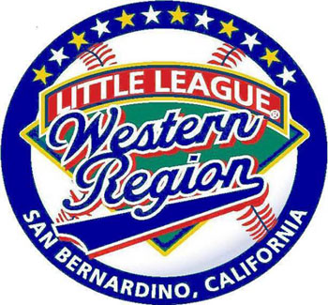

“Where Safety comes First”
2025 Safety Plan


League ID# : ________

Table of Contents

Requirement 1 2025 Board of Directors 3
League Safety Officer Information 3
Requirement 2 Distribution of Safety Manual 3
Requirement 3 Emergency Phone Numbers 4
Covid-19 Guidelines 4
Requirement 4 Volunteer Background Checks 6
NEW 2025 Abuse Awareness Training 8
Safe Sports Act 9
Requirement 5 Coach Fundamental Training 10
Requirement 6 Safety Manual & First-Aid Training 10
Requirement 7 Field Inspections and Storage Procedures 10
Pregame Check List 11
Requirement 8 Annual Facility Survey 12
Requirement 9 Concession Stand Guidelines 12
Requirement 10 Inspection of Equipment 13
Requirement 11 Accident Reporting Procedure 14
League Safety Officer Information 14
Requirement 12 First Aid Kits 15
Communicable Disease Procedures 15
Requirement 13 Enforcement of Little League Rules 15
Lighting & Weather 17
Hydration 18
Requirement 14 Submitting Player, Manager and Coach Data 19
Requirement 15 Complete survey questions in the LL Data Center 19
Concussions Concussion Prevention Policy 19
Accident Notification Form 21

___________ Little League
Safety Program

Safety Mission Statement

________ Little League is a non-profit organization run by volunteers whose mission is to provide an opportunity for our community’s children to learn the game of baseball and softball in a safe and friendly environment.

2025 Board of Directors

Requirement 1:
Title Name E-Mail Phone Number
President
Vice President
Secretary
Treasurer
Safety Officer
Information Officer
Player Agent
Umpire in Chief
Coaches Coordinator
Board Member
Board Member

Distribution of Safety Manual
Requirement 2:
Each team will receive a paper copy of this safety manual. Managers and or Team Safety Officers should have a copy of the safety manual at all league functions.

EMERGENCY PHONE NUMBERS

Requirement 3:
Police Emergencies 911
Non-threat Emergency 311
Fire 911
Non-Emergency
Ambulance Dispatch ADD PHONE NUMBERS
County Health District
Animal Control
Park Marshal

NEIGHBORING HOSPITALS

Add hospitals and quick cares for your area
NAME: University Hospital
ADDRESS: 123 Main St. City, State
PHONE NUMBER: (555) 555-5555

Requirement 3: COVID-19 Guidelines NEW FOR 2021
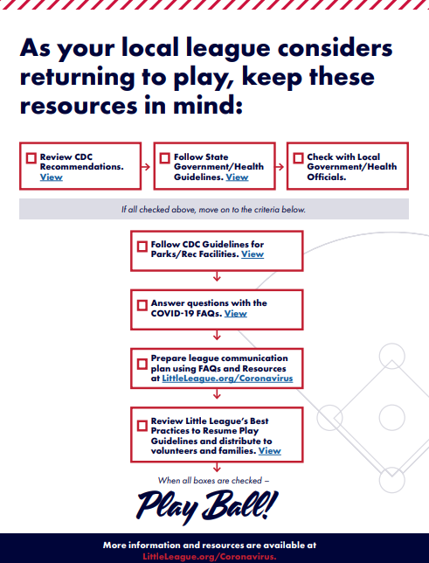

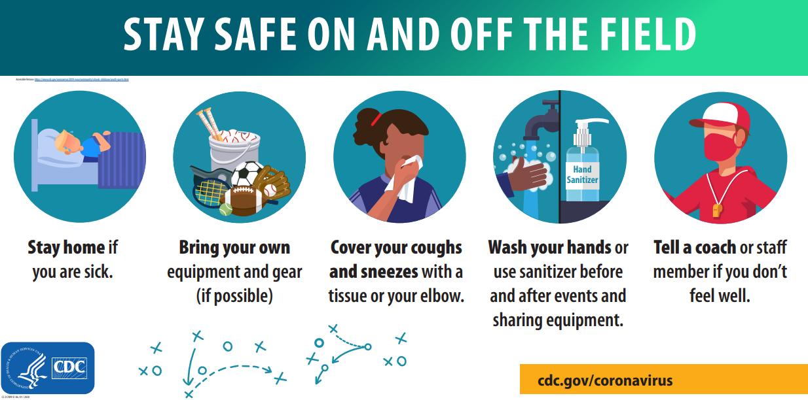

Background Checks & Abuse Awareness Training
Requirement 4:
Little League International has established criteria for each chartered league’s performance of an investigation into the background of all individuals who volunteer in any capacity. Each volunteer will be required to complete a volunteer application from and provide a copy of their government issued photo identification. The minimum requirement for these background investigations is verification that volunteers are not registered sex offenders. To provide additional protection to the children we will submit a list of all volunteers to JDP. A background investigation that will list any convictions nationwide will be completed. Upon clearance of individual background investigations all volunteers will be notified by The Board of Directors.
Background Checks Regulation 1 Annual October 1 to September 30
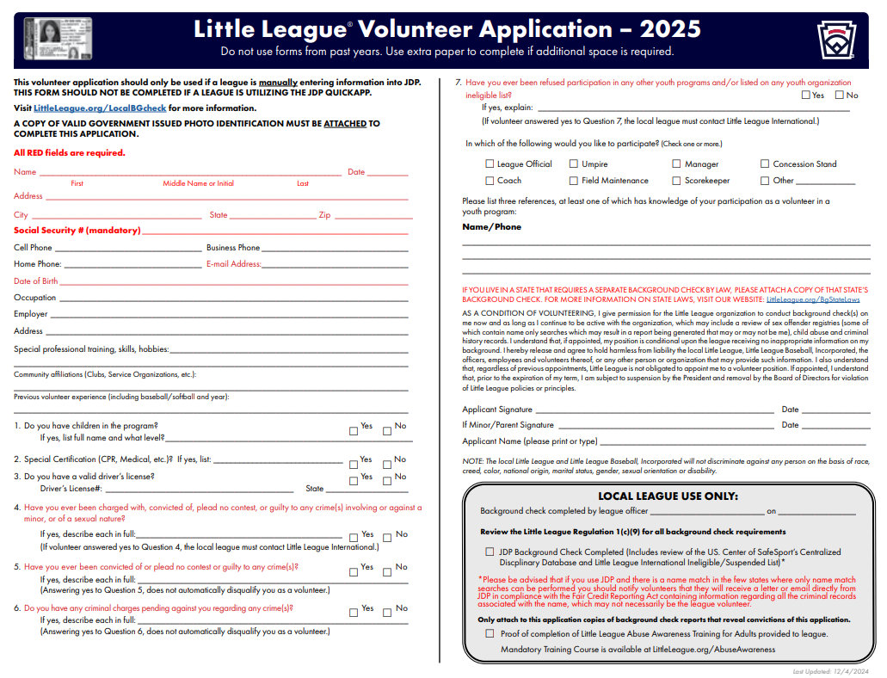

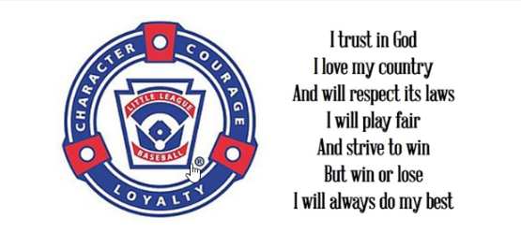

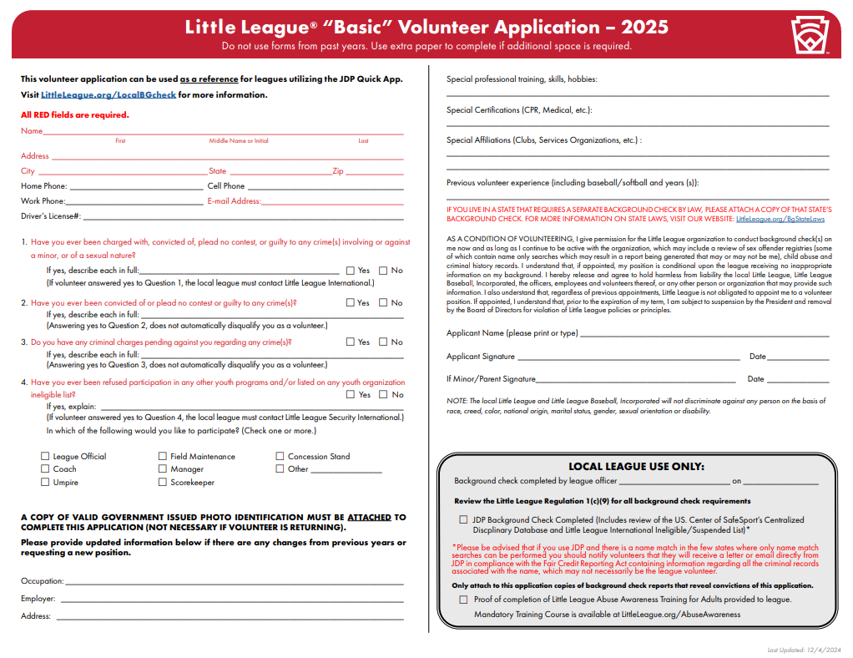

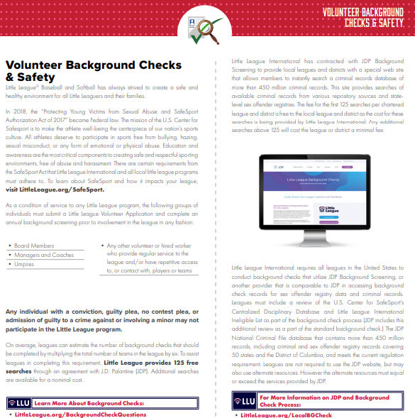

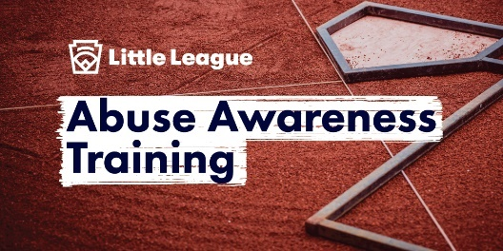

Requirement 4 Abuse Awareness Training:
Beginning with the 2024 Little League regular season, Abuse Awareness Training will be a mandatory part of the annual Little League Volunteer Application and background check. This requirement will also be incorporated into the ASAP program. During the ASAP Submission process in the Little League Data Center, leagues will be asked to provide information about how they are implementing and tracking this requirement in their local league program.
- All volunteers in your league are required to complete Abuse Awareness.
- Please provide the number of volunteers in your league that have completed the training.
Our league will require 100% of our volunteers to complete the training.
- Please share how your league monitored compliance.
Volunteers are required to complete Abuse Awareness training each year.
NEW for 2025 Little League has launched the new Little League Abuse Awareness Course, available for all volunteers to complete at LittleLeague.org/AbuseAwareness.
This course, which serves as a replacement for the programs previously available through third-party organizations like USA Baseball, is custom to the Little League program and provides an easier learning experience for volunteers. This course is required to be completed by all volunteers each year.
- The following training methods have been used:
- SafeSport
- Little League Abuse Awareness Training
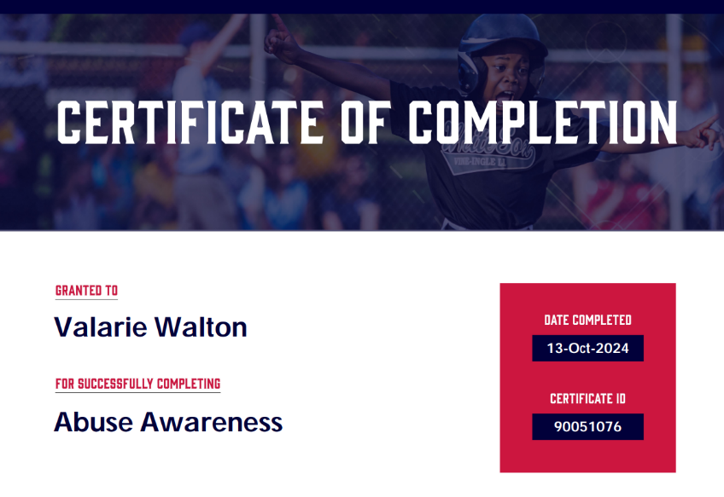

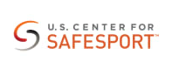
Safe Sports Act

- “Protecting Young Victims from Sexual Abuse and SafeSport Authorization Act of 2017” became federal law in 2018
- The goal of SafeSport is to protect children from abusive situations by engaging more people in the reporting and education processes
- A volunteer now can be held legally responsible if they have firsthand knowledge and fail to report any type of Child Abuse to the correct parties
- SafeSport covers all types of Child Abuse both physical and psychological
- Little League International and all local little league programs must adhere to the following requirements from the SafeSport Act:
- Reporting of Abuse involving a minor to the proper authorities
- All volunteers of a local league are now mandated reporters and could face criminal charges if the league chooses to ignore, or not report to the proper authorities, any witnessed act of child abuse, including sexual abuse, within 24 hours.
- Local leagues must be aware of the proper procedures to report any type of abuse in their state. Please reference www.LittleLeague.org/ChildAbuse
- Leagues must adopt a policy that prohibits retaliation for “good faith” reports of child abuse.
- Leagues must adopt a policy that limits one-one-one contact with minors.

https://www.littleleague.org/player-safety/child-protection-program/safesport-resources-parents/



League Training Dates and Times

Requirement 5: Date Location Time
Coach Fundamental Training: LEAGUE FILLS IN THIS INFORAMATION

DO NOT PUT TBA! YOU MUST PUT THE DATE/LOCATION

Requirement 6: Date Location Time
Safety Manual & First-Aid Training: LEAGUE FILLS IN THIS INFORAMATION
Requirement 2: Each team will receive a paper copy of this safety manual. Managers and or Team Safety Officers should have a copy of the safety manual at all league functions.

Field Inspections and Storage Procedures
Requirement 7:
BERORE THE SEASON STARTS
- Familiarize yourself with the safety materials.
- Appoint a Safety Parent for your team. They need to be at all the games and have a cellular phone. It can be an Assistant Coach.
PRIOR TO EACH GAME
- Complete a field safety checklist. Report any problems to your commissioner. Or to the League Safety Officer.
- Check the team equipment for any problems. Report any equipment problems to the Equipment Manager.
- Check the contents in your team’s first aid kit. Contact the League Safety Officer for any items that need to be replaced.

STORAGE SHED
The following applies to the entire storage shed used by the League and applies to anyone who has been issued a key to use those sheds.

- All individuals are aware of their responsibility for the orderly and safe storage of rakes, shovels, and bases.
- Before you use any equipment located in the shed (lights, scoreboards, etc.) please read the written operating procedures for that equipment.
- All chemicals or organic materials stored in the sheds shall be properly marked and labeled as to its contents.
- Any witnessed “loose” chemicals or organic materials within these sheds should be cleaned up and disposed of as soon as possible to prevent accidental poisoning.

PRE-GAME FIELD INSPECTION CHECK LIST
MANAGER’S NAME:
FIELD:
DATE: Time:
Field Condition | Yes | No | Catchers Equipment | Yes | No
Backstop Intact |  |  | Hockey Catchers Helmet
Home Plate Intact |  |  | Dangling Throat Guard
Bases Secure |  |  | Helmets
Pitcher’s Mound Safe |  |  | Catcher’s Mitt
Batter Box Lined/Level |  |  | Chest Protector
Infield Fence Repair |  |  | Shin guards
Outfield Fence Repair |  |  | Dugouts | Yes | No
Foul Lines Marked |  |  | Fencing Needs Repair
Infield Need Repairs |  |  | Bench Needs Repair
Outfield Need Repairs |  |  | Trash Cans
Warning Track |  |  | Clean Up Is Needed
Coaches’ boxes Lined
Free of Foreign Objects |  |  | Spectator Area | Yes | No
Grass Surface Even |  |  | Bleachers Need Repair
 |  |  | Protective Screens Ok
Player Equipment | Yes | No | Bleachers Clean
Batting Helmets |  |  | Parking Area Safe
Jewelry Removed |  |  | Safety Equipment | Yes | No
Shoes/Bats Inspected |  |  | First-aid Kit Each Team
Face Mask (Minor/Mjrs) |  |  | Medical Release Forms
Proper Cleats |  |  | Ice Pack/Ice
Athletic Cups (boys) |  |  | Safety Manual
Full Uniform |  |  | Injury Report Forms
Bats Meet Standards |  |  | Drinking Water
REPORT ANY PROBLEMS TO YOUR COMMISSINER OR SAFETY OFFICER.
Turn this form into the concession stand or to your division Rep.

Requirement 8:
Annual Little League Facility Survey will be submitted in the Data Center.

Concession Stand Guidelines

Requirement 9:
Every worker must be instructed on these guidelines before they can work.

Wash your hands regularly:
- Use soap and warm water.
- Rub your hands vigorously as you wash them.
- Wash all surfaces including the backs of hands wrists, between fingers and under fingernails.
- Rinse hands well.
- Dry hands well.
- Dry hands with paper towels.
- Turn off water using paper towels, instead of your bare hands.

Wash your hands in this fashion before you begin work and especially after performing any of these activities:
- After touching bare human body parts other than clean hands and clean exposed portions of arms.
- After using restrooms.
- After caring for or handling animals.
- After coughing, sneezing, using a handkerchief or disposable tissue.
- After touching soiled surfaces.
- After drinking, using tobacco, or eating.
- During food preparation.
- When switching from raw to ready to eat foods.
- After engaging in activities that contaminate the hands.

Basic Rules:
- Menu… smaller is better. No salads cut up fruit or vegetables, no food prepared at home.
- Cook food thoroughly. Use a meat thermometer. Keep hotdogs and burgers at 41 degrees when cold and cook to 155 degrees or above when hot.
- Rapidly reheat foods to 165 degrees. Slow cooking devices may activate bacteria and never reach killing temperatures.
- All foods that require refrigeration must be cooled to 41 degrees F. as quickly as possible and held there until ready to use. To cool foods quickly, use the ice water bath (60% ice and 40% water), stir the product frequently, or place their food in shallow pans no more than 4 inches in depth and refrigerate. Pans should not be stored one a top of the other and lids should be off or afar until the food is completely cooled. Check the temperature periodically to see if the food is cooling properly. DO NOT LEAVE FOOD OUT AT ALL!!
- FREQUENT AND THOROUGH HANDWASHING IS REQUIRED.
- Only healthy people should prepare and serve food. Anyone with any symptoms of disease (cramps, nausea, fever, vomiting, diarrhea, cough etc.) or who has open sores or infected cuts on the hands should not be allowed in the food concession area. Workers’ clothes should be clean, and they should not smoke in the concession area. Hair restraints are recommended.
- Food handling: Avoid hand contact with raw food, ready-to-eat foods, and food contact surfaces. Use a utensil and/or glove.
- Use disposable utensils for food service. Keep your hands away from food contact surfaces and never reuse disposable dishware. Ideally utensils should be washed in a four-step method: (1) Hot soapy water, (2) Rinsing in clean water, (3) Chemical or heat sanitizing, (4) Air drying.
- Ice that is used to cool cans/bottles should not be used in cup beverages. And it should be stored separately. Use scoop to dispense ice, never use hands.
- Wiping clothes should be rinsed and stored in a bucket sanitizer. (1-gallon water and ½ tsp. chlorine bleach. Change the solution every 2 hours.
- Insect control and waste. Keep food covered to protect it from insects. Store pesticides away from food. Place garbage and paper waste in a refuse container with a lid that fits tightly. Dispose of all water in the restrooms, do not pour outside. All water that is used should be potable from an approved source.
- Keep food stored off the floor at least 6 inches. After your event is finished, clean the concession area and discard any unusable food. Do not save food for reheating.

THE TOP SIX CAUSES FOR ILLNESS
- Inadequate cooling and cold holding.
- Preparing food too far in advance of service.
- Poor personal hygiene and infected personnel.
- Inadequate reheating.
- Inadequate hot holding.
- Contaminated raw foods and ingredients.
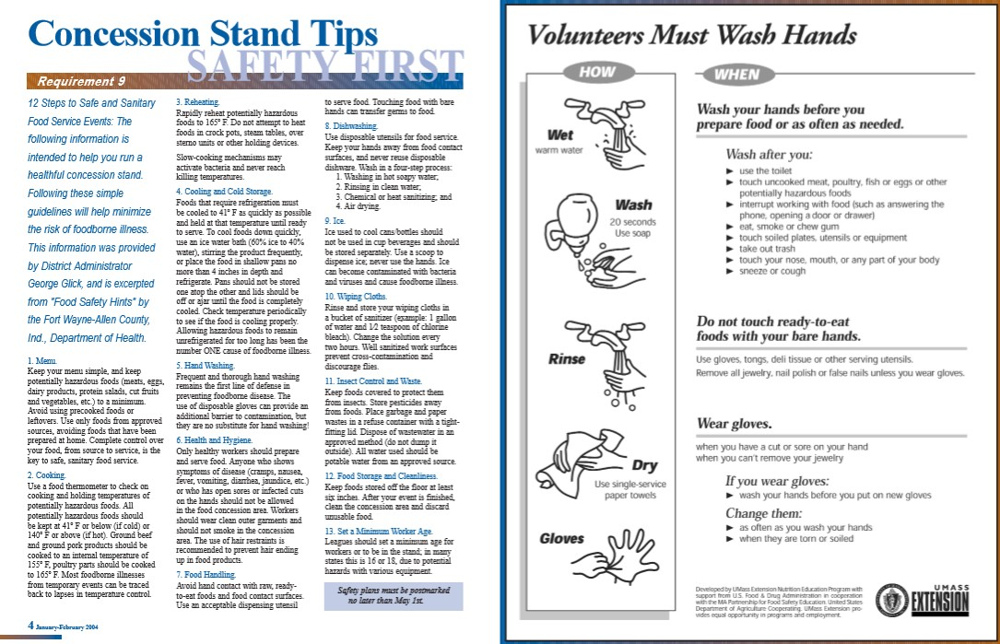

Inspection of Equipment
Requirement 10:
- This Little League requires regular inspection of playing equipment.
- Unsafe equipment should not be given in team equipment bags.
- Manager’s Coaches and Umpires are required to inspect equipment prior to each use.
- Bad equipment will be logged and will be removed and destroyed.

Accident Reporting Procedure

Requirement 11:
What to Report: An incident that causes a Payer, Manager, Coach or Umpire to receive medical treatment or first aid must be reported to The Safety Officer.

When to Report: All such incidents described above must be reported to The Safety Officer within 24 to 48 hours of the incident.
The Safety Officer is NAME: LEAGUE FILLS IN INFORMAION
Cell Number:
Home Number:
Email:

How to Make a Report: Reporting incidents can come in a variety of forms. Most typically they are telephone conversations. At a minimum, the following information is needed.
- The name and address of the injured person.
- The date, time, and location of the incident.
- A completely detailed description of the incident as possible.
- The preliminary estimation of the extent of the injury.
- The name and phone number of the person making the report.
- Names and phone numbers of any witnesses.

In your safety packet you will find the injury report forms. If your Safety Parent is there, he/she can assist you in getting the front of the form filled out. Then a call is to be made to The Safety Officer reporting the incident within 48 hours. Little League insurance is supplemental insurance to the insured’s own insurance. There is a small deductible.

How to Replace the Injury Report Forms: The forms can be replaced by The Safety Officer or downloaded from www.leagueleague.org found under forms and publications.

FIRST AID KITS
Requirement 12:
Each team is provided with a league issued first aid kit. Each kit includes the following.
(10) Adhesive sterile bandage
(2) Extra-large adhesive sterile bandage
(2) Non-adherent pads 2 x 3
(2) Gauze pad 12-ply 3 x 3 sterile
(1) Adhesive tape
(2) Instant cold compress 4 x 4
(3) Triple antibiotic ointment
(3) Antiseptic towelette
1/8 oz. Burn Cream
(3) Sting relief wipes
(1) Tweezers

Communicable Disease Procedures

- Bleeding must be stopped, the open wound covered, and the uniform changed if there is blood on it before the athlete may continue.
- Routinely use gloves to prevent mucous membrane exposure when contact with blood or other body fluids is anticipated (Provided in the first aid kit).
- Immediately wash hands and other skin surfaces if contaminated with blood.
- Clan all blood contaminated surfaces and equipment.
- Managers, Coaches, and Volunteers with open wounds should refrain from all direct contact until the condition is resolved.
- Follow accepted guidelines in the immediate control of bleeding and disposal when handling bloody dressings, mouth guards and other articles containing body fluids.

Enforcement of Little League Rules
Requirement 13:
- All volunteers must have a volunteer application filled out and on file with the League. Our league will provide annual background checks.
- No laminated bat shall be used… (rule 1.10)
- The traditional batting donut is not permissible… (rule 1.10)
- A pitcher shall not wear any items on his/her hands, wrists or arms which may be a distraction to the batter. White long sleeve shirts are not permitted… (rule 1.11)
- Pitcher shall not wear sweat bands on his/her wrists… (rule 1.15)
- Players must not wear jewelry… (rule 1.11)
- Catcher must wear a catcher’s mitt… (rule 1.12)
- All batters must wear protective batting helmets, all helmets must bear the NOCAE stamp, No painting, or stickers on helmets… (rule 1.16)
- All male players must wear athletic supporters. Male catchers must wear the metal, fiber, or plastic type protective cup.
- A catcher’s helmet must have the dangling type of throat protector and catcher’s helmet during infield/outfield practice, pitcher warm-up and games.
- Skull caps are not permitted… (rule 1.17)
- Each team is allowed three coaches in the dugout…
- Coaches are encouraged to discourage “horseplay”
- No on deck batters are allowed in the Majors and below… (rule 1.08)
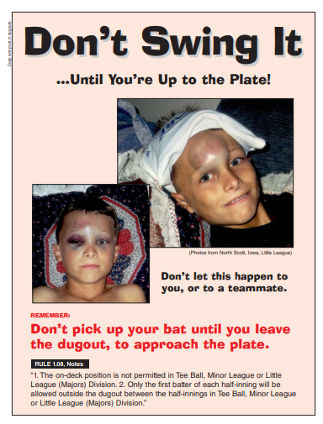

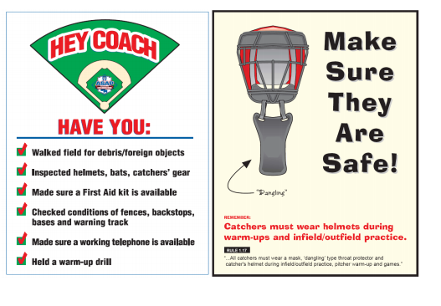

Lightning Facts and Procedures

Lighting and Weather
Consider the following facts:

- The average lightning stroke is 6-8 miles long.
- The average thunderstorm is 6-10 miles wide and travels about 25 miles an hour.
- On average, thunder can only be heard over 3-4 miles, depending on humidity, terrain, and other factors. This means that by the time you hear the thunder, you are already in the risk area for lighting strikes.

Rule of Thumb: The ultimate truth about lighting is that it is unpredictable and cannot be prevented. Therefore, a manager or coach who feels threatened should contact the head umpire and recommend stopping play and clearing the field. In our league the umpire makes the decision as to whether play is stopped. Once play is stopped, take the kids to safety until play resumes or the game is called.

Where to Go? No place is safe from lightning threat, but some places are safer than others. Constructed buildings are usually the safest. Most people will find shelter in a fully enclosed metal vehicle with the windows rolled up. If you are stranded in an open area, put your feet together, crouch down and put your hands over your ears to prevent eardrum damage.

Where not to go? Avoid high places and open fields, isolated trees, unprotected gazebos, rain or picnic shelters, dugouts, flagpoles, light poles, bleachers, metal fences and water.

First Aid for a Lightning Victim:
- Call 911 immediately.
- Typically, the lightning victim has similar symptoms as that of someone having a heart attack. Consider: will moving cause more injury. If the victim is in a high-risk area, determine if movement is necessary. Lightning does strike twice in the same place. If you are not at risk, and moving is a viable option, you should move the victim.
- If the victim is not breathing, start mouth to mouth resuscitation. If it is decided to move the victim, give a few quick breaths prior to moving the victim.
- Determine if the victim has a pulse. If no pulse is detected, start cardiac compressions as well.

NOTE: CPR should only be administered by a person knowledgeable and trained in the technique.

Remember: Safety is everyone’s job. Prevention is the key to reducing accidents to a minimum. Report all hazardous conditions to the Safety Officer or another Board Member immediately. Do not play on an unsafe field or with unsafe equipment. Check the team’s equipment prior to each use.

Hydration
Managers are required to bring water to each practice and game.
Players are encouraged to bring bottled water or sports drinks.
Tips to Prevent Heat Illness:
- Know that once you are thirsty you are already dehydrated.
- Drink before you become thirsty.
- Drink plenty of liquids like water, or sports drinks every 15 minutes.
- Water seems to be the preferred beverage. Water has many critical functions in the body that are important for performance. They include carrying oxygen and nutrients to exercise muscles.
- Do not drink beverages with caffeine before practice or games. Caffeine can increase the rate of dehydration.
- Do not exercise vigorously during the hottest time of the day.
- Practice in the morning and during the latter part of the evening.
- Wear light color loose cloths.
- Use sunscreen to prevent sunburn.
- If you begin to feel faint or dizzy stop your activity and cool off by sitting in the shade, air-conditioned car or using a wet rag to cool you off.

How is it treated?
Emergency medical treatment is necessary. If you think someone has heatstroke, call 911 or a doctor immediately. In the meantime, give first aid as follows:
- Move the person to a shady area.
- Cover the person with a wet sheet and keep the sheet wet for cooling from evaporation.
- Fan the person with paper or an electric fan (preferably not cold air).
- Sponge down the body, especially the head, with cool water.
- Continue giving first aid until the body feels cool to the touch.
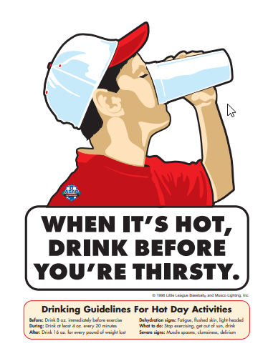
- If the person is conscious, let them sip water, fruit juice, or a soft drink.

Submitting Player, Manager and Coach Data
Requirement 14:
Player, Manager, and Coach information will be submitted through the Little League Data Center at www.littleleague.org
DEADLINES: March 24, 2025, for early submission deadline
April 7, 2025, for league deadline

Requirement 15:
We will answer the survey questions in the Little League Data Center.

Concussions
All 50 states have laws specific to the management of concussions and head injuries. Some states require not just the leagues but DA’s, ADAs, and umpires to undergo annual training.
- Some states may affect only school-based activities, but many also address any group using school facilities or grounds for athletic purposes.
- Little League has developed a concussion overview page for each state that will be like the Child Abuse page.
- The CDC (Centers for Disease Control and Prevention) website is a great tool for leagues to encourage their managers/coaches, parents, and players to review concussion information • www.cdc.gov/concussion/HeadsUp/youth.html Concussions
- DA’s and local league volunteers must also be aware of their state’s respective laws, especially during any Special Games events or International Tournament games being hosted by the district.
- Failure to adhere to these laws could expose the district and/or host to unwanted liability and penalties • Some states require that the participant and a parent/guardian must sign and acknowledge that they understand the risks of concussions before they can participate
- The majority of states also require immediate removal from competition if a person has sustained a concussion and that they cannot return until being released in writing by a medical professional.
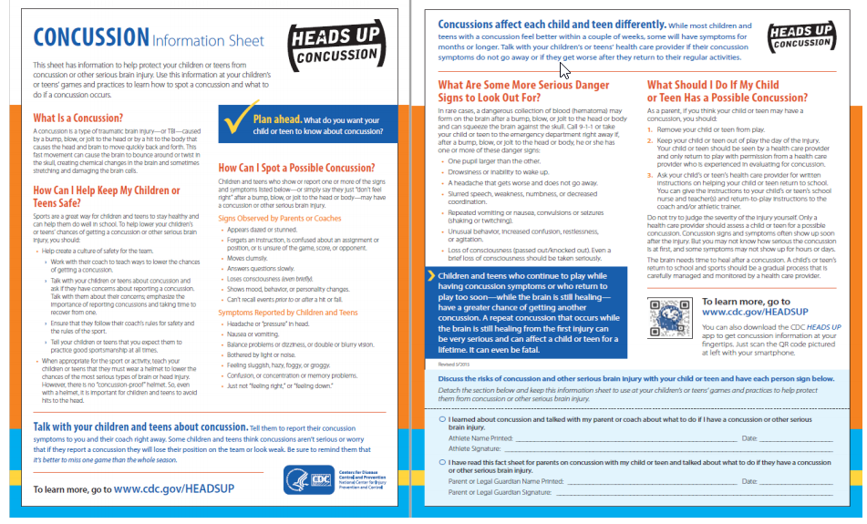
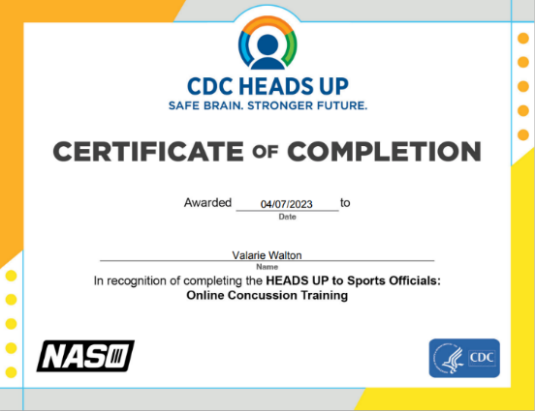

YOUR Little League Concussion Prevention, Treatment and Management Policy
The Legislature enacted a law which requires youth sports organizations to adopt a policy concerning the prevention and treatment of injuries to the head which may occur during a youth’s participation in competitive sports, including, without limitation, a concussion of the brain.
A concussion is a brain injury that results from a bump, blow or jolt to the head or body which causes the brain to move rapidly in the skull and which disrupts normal brain function. The Centers for Disease Control and Prevention of the United States Department of Health and Human Services estimates that as many as 3.8 million concussions occur each year in the United States which are related to participation in sports and other recreational activities. Athletes who continue to participate in an athletic activity while suffering from a concussion or suffering from the symptoms of an injury to the head are at greater risk for catastrophic injury to the brain or even death. Ensuring that a Little League player who sustains or is suspected of sustaining a concussion or other injury to the head receives appropriate medical care before returning to baseball activity will significantly reduce the child’s risk of sustaining greater injury in the future.
THEREFORE, YOUR Little League hereby adopts the following policy for purposes of prevention, treatment, and management of injuries to the head that may occur during a player’s participation in the Little League program, including, without limitation, a concussion of the brain:
1. Prior to a team’s first practice each season, every manager, coach, and adult assistant shall:
a) Familiarize themselves with the CDC publication “Heads Up – Concussion in Youth Sports – A Fact Sheet for Coaches”. This publication will be provided to all such individuals by the League Safety Officer or other Board members; and,
b) Complete the CDC on-line training course at:
https://www.train.org/cdctrain/course/1089818/
A copy of the Certificate of Completion for each of the above individuals shall be submitted to the League Safety Officer.
2. If a Little League player sustains, or is suspected of sustaining, an injury to the head while participating in any Little League game or even the player must:
a. Be immediately removed from the game or event; and
b. May only return to Little League activity if the parent or legal guardian of the player provides a signed statement from a provider of health care indicating that the youth is medically cleared for Little League participation and the date on which the player may return to participation.
3. The Little League player and his or her parent or legal guardian must sign the statement below acknowledging that they have read and understand the terms and conditions of the policy and agree to be bound by the policy.
YOUR Little League Concussion Prevention, Management and Treatment Policy
Player and Parental Acknowledgement
We, the undersigned, acknowledge that we have been provided with a copy of the YOUR Little League Concussion Prevention, Management and Treatment Policy, and that we have read and understand the policy, or it has been read to us and we understand the same. We hereby agree to follow all procedures set forth in said Policy at all times during which our son or daughter participates in Little League activities and events.
Dated: ___________________ _________________________
Player
Dated: ___________________ _________________________ _________________________
Parent/Legal Guardian Parent/Legal Guardian

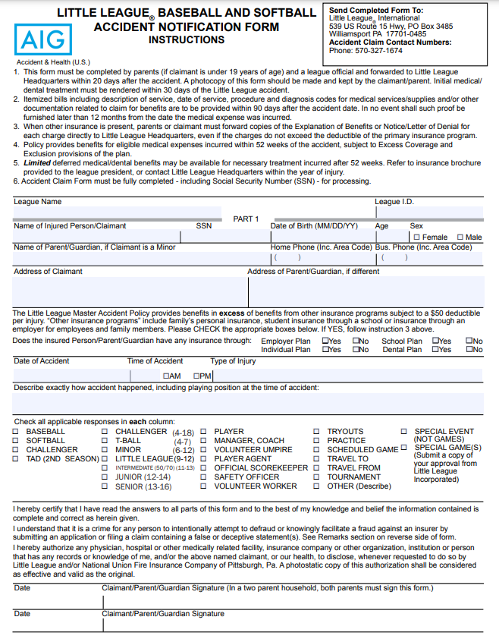
Accident Notification Form Page 1 (Parent/Guardian Statement)

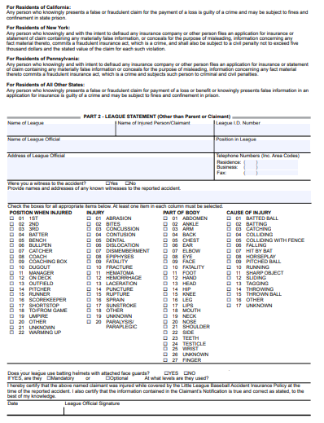
Accident Notification Form Page 2 (League Use Only)

