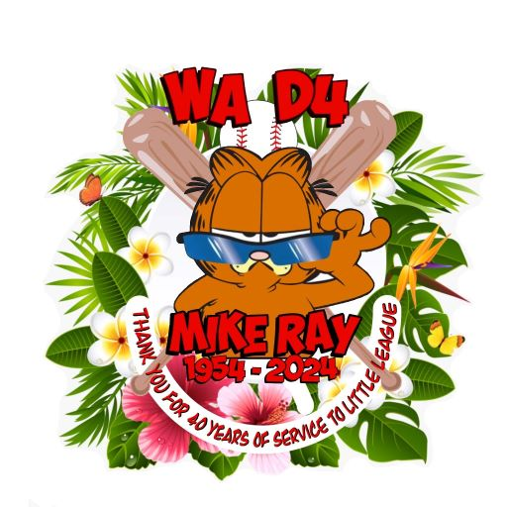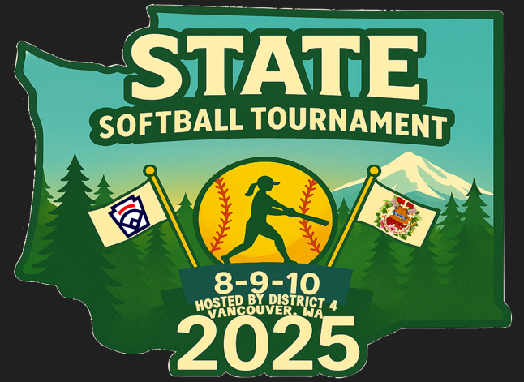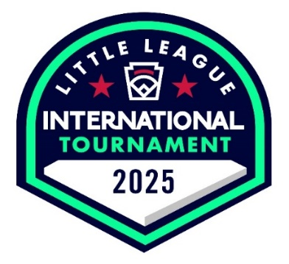
Dear Little League Presidents, Managers, and Coaches:

Congratulations on winning your District 8-10 Softball tournament and advancing to the Washington State Tournament. District Four is proud to host this tournament, along with Columbia Little League, in Vancouver, Washington. Please review this packet carefully as it includes information unique to this tournament.

The following information about your team will help our district and our host league put on a great tournament event. Please email the following to me at washd4da@gmail.com: your team’s name, number of players, manager’s name, phone number, and email address right away, so that I have someone to contact if anything changes or we need something from your team.

Please note, the Little League (Majors) Baseball State tournament is also happening in our area, in District 6, starting the same weekend.

Priority Information:
- A mandatory managers meeting will be held at 6:00 PM on Friday, July 11th at the Columbia Little League clubhouse facility (900 N Garrison Rd., Vancouver, WA), upstairs.
- Bring your tournament binder that includes your team affidavit, player verification packets, and other documentation required for team tournament participation (as listed in the tournament rules of the current Little League Rule Book.) Please be sure all your tournament documentation is signed by your Player Agent, League President and District Administrator. You will turn this over at the meeting for review and signature by D4 staff.
- Complete the Announcer sheet and put it in a plastic sleeve in your binder. This will save you from filling one out for each game and the plastic will help protect it as we use it for each game.
- We will provide tournament lineup cards for each game to be used by all teams.
- We will have district personnel (including umpires) and representatives of the host league to answer questions about tournament conduct, field specifics, and practice field availability.
  - To sign up for practice fields, contact the Columbia President, Chris DiPalma, at 617-953-5201 or by email at chris@columbiall.org
- The tournament is a modified double elimination format. Please be aware that some teams will have two games in a day, possibly two days in a row, and plan pitching accordingly. You are responsible for knowing the current year’s Little League Softball Rules and Regulations, including all tournament rules.
- We will play with pink balls. If your pitcher has a pink glove we can switch to the optic yellow. Please inform the Tournament Director prior to the start of the game, if possible.
- Opening ceremonies are 9:00 am on Saturday, July 12, at Columbia Little League. Teams must arrive and be ready to line up by 8:30 am for presentation onto the field. Please bring your District Tournament flags for the parade and be in uniform. This should be a fun photo opportunity for fans.
- No coolers are allowed in the ballpark. Make sure families plan accordingly. No alcohol, tobacco products, or vaping. This is against Little League rules and is illegal in the State of Washington.

It is highly recommended that teams bring any necessary equipment and supplies, such as extra uniforms, game gear (zip ties for throat guards), and first aid kits. This will ensure that players are well-prepared for any contingencies that might arise during the event.

To familiarize themselves with the venue, teams are encouraged to arrive a day early, if possible, and take the opportunity to explore the facilities. This can help alleviate pre-game jitters and give players a sense of confidence before the competition formally begins. Parents and supporters are also reminded to cheer enthusiastically yet respectfully, setting an example of good sportsmanship for young athletes. Tournament organizers have also arranged for a special opening ceremony to welcome all participating teams. This event will take place at 9:00 AM on July 12th at the Columbia Little League fields and will feature a parade of teams, speeches, and a celebratory first pitch. Teams are encouraged to arrive by 8:30 and wear their full uniforms for the occasion.

We hope that teams will focus on fostering sportsmanship and camaraderie, emphasizing the values of teamwork and fair play. Coaches and managers are encouraged to hold brief sessions with players and families to discuss the importance of respect for opponents, umpire decisions, and the overall spirit of the game. By instilling these principles, teams can contribute to a positive and inspiring atmosphere throughout the tournament. It’s ok to celebrate a good play, no matter which team made it.

Since its humble beginnings, the mission of Little League has remained unchanged; to provide a wholesome, healthy activity for children using the ball field as a classroom to instill discipline, teamwork, sportsmanship, and fair play and to establish a set of values to guide them into adulthood and, hopefully, responsible citizenship. These were the reasons Carl Stotz founded the program and are why it exists today.

We appreciate the dedication and effort your team is putting into making this tournament a resounding success. The collaboration between participants, organizers, and supporters creates a truly special environment where young athletes can thrive. The commitment to preparation, sportsmanship, and community spirit is what makes events like this memorable not just for players but for everyone involved. We want to thank the parents and spectators for supporting the Little League Program. As you know, Little League offers opportunities to children of all ages and circumstances to come together in a spirit of teamwork, to learn, to compete, and have a lifetime of memories. We are sure that your spectators will want to display a spirit of sportsmanship and continue to shout words of encouragement to your team.

So as the tournament approaches, don’t forget to enjoy the journey and celebrate the achievements that have brought your team here. Every pitch, every run, and every cheer contribute to the tapestry of unforgettable moments that sports embody. Let this be an opportunity for growth, learning, and building lasting connections with fellow teams and supporters.

We are confident that your participation will enrich the tournament and leave a positive impact on all attendees. Let us work together to create an event that truly celebrates the joy and spirit of the game. We wish you the best of luck in the tournament. If you still have any questions about your participation in the state 8-10 Softball Tournament, please feel free to contact me by phone or text at 360-606-5734 or by email at washd4da@gmail.com.

Sincerely,

Ann Leggett
Tournament Director
District 4 Administrator

