We are excited to be hosting our opening ceremonies Friday, July 24th at the Fish Sticks game! The Fish Sticks are our own version of the Savannah Bananas!

Opening ceremony will be approximately 5:45-6:15pm
*** Please bring your District Championship Banner for display!

- Fish Sticks game is 6:35, game lasts approx. 2 hours

- On-field activities for players before the game (players, bring your glove!), plus fun contests for kids between innings. They know how to put on a show!

- Full food & beverage concessions, including a beer garden for 21+ attendees

- Tickets are $10 for all kids and attendees.


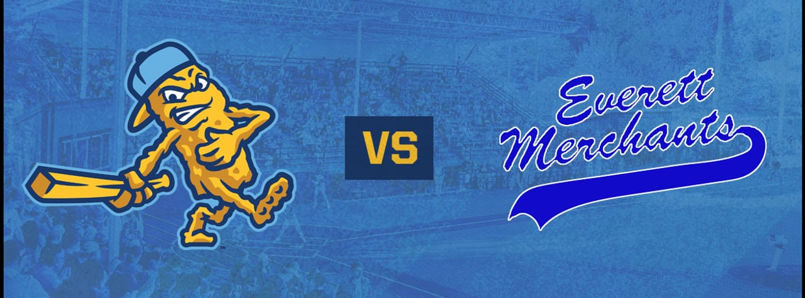
Everett Merchants vs. DubSea Fish Sticks | Friday, July 24, 2026
Yaks Collegiate vs DubSea Fish Sticks

click here to purchase tickets

Everett Merchants vs. DubSea Fish Sticks | Friday, July 24, 2026
Friday night baseball returns to The Fryer as the DubSea Fish Sticks host the Everett Merchants for a summer matchup that sets the tone for the weekend. With July winding down and the season in full swing, this game brings together competitive baseball, lively entertainment, and the relaxed energy that makes Friday nights at the ballpark so popular.
As fans arrive, the stadium fills with music and conversation as groups settle into their seats and prepare for a night of baseball under the lights. Fridays at Mel Olson Stadium have a social feel, making this a great night for coworkers, families, and friends looking to kick off the weekend together.
On the field, the Fish Sticks and the Merchants face off in a fast-paced summer collegiate matchup that keeps the action moving from the opening inning through the final out. Between innings, the game day crew keeps the crowd engaged with interactive entertainment and fan moments that add to the overall experience.
The Fresh Catch Concession Stand will be serving ballpark favorites throughout the night, while The Ice Chest beer garden offers cold beer, cider, and seltzers that pair perfectly with a warm summer evening. It is an easy night to relax, enjoy great food, and take in baseball in a fun, community driven environment.
🕔 Gates open: 5:05 PM
*** Opening ceremonies approximately 5:45 – 6:15 pm
⚾ First pitch: 6:35 PM

If you are looking for an affordable and entertaining way to start your weekend, Friday night at The Fryer delivers. Join us at Mel Olson Stadium inside King County’s Steve Cox Memorial Park and enjoy a summer night of baseball with the DubSea Fish Sticks. Go Sticks!

Date Jul24
Doors Open5:05 PM

Location

Mel Olson Stadium
1321 SW 102nd St
Seattle 98146
United States
(opens in a new tab)

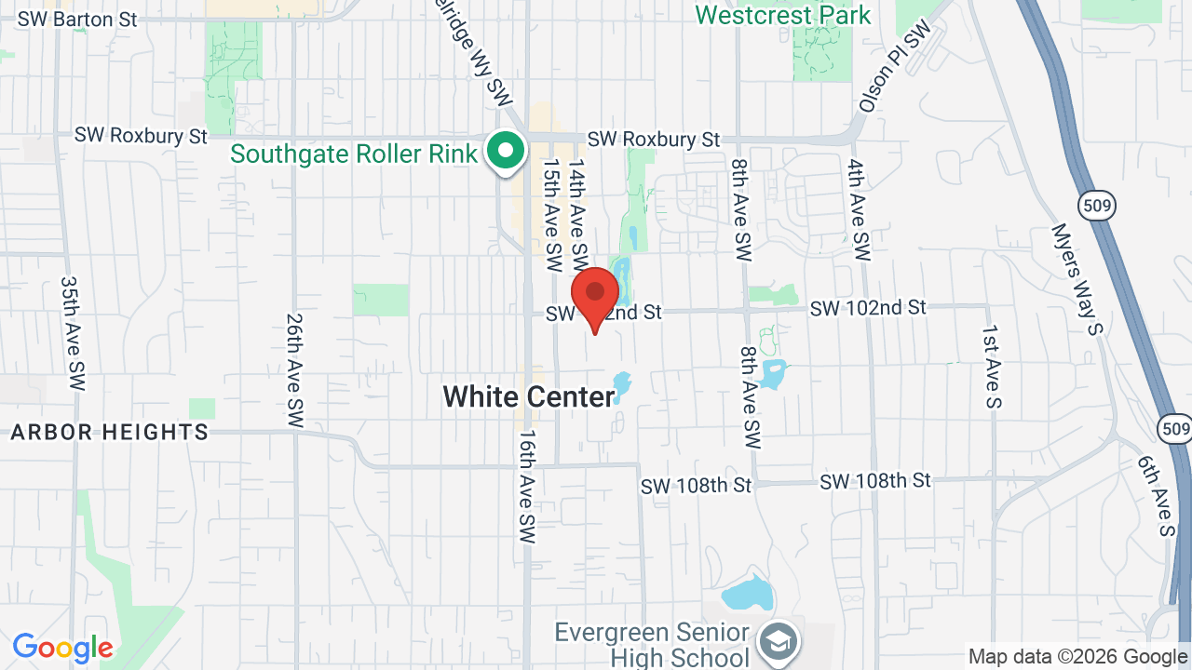
(opens in a new tab)
Everett Merchants vs. DubSea Fish Sticks | Friday, July 24, 2026
Mel Olson Stadium
1321 SW 102nd St
Seattle 98146
United States

