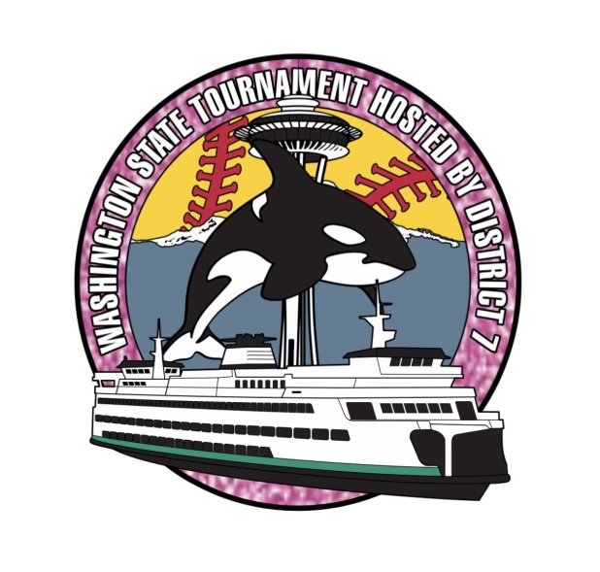 DISTRICT 7 LITTLE LEAGUE

Dear Washington State District Administrators,
Enclosed is the packet for the Little League Softball State Tournament hosted by District 7. Please go through the information included, should you have any questions do not hesitate to contact me.
I ask that you check the game bracket, ensuring that your district is included. In the event that your district is not listed on the bracket or that your district has withdrawn, please contact me as soon as possible. Once determined, please forward this packet to the winning manager of your District Little League Softball All Star team.
If you would like to sending umpiring crews to this tournament, please contact David Gearhard drgump11@comcast.net or 206-612-2575 as early as possible so that he can properly schedule the games.
Also, if you have parents who are interested in announcing or scorekeeping please contact Del.
Should you have any questions please feel free to contact me.

Thank you,
Del Rivero
District 7 Administrator
deljrivero@gmail.com
206-427-8333

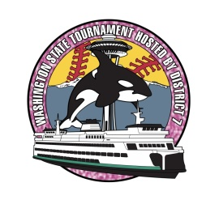
Dear Little League Presidents, Managers, and Coaches:
Congratulations on representing your Little League District at the Little League Softball State Tournament. District 7 is proud to host this tournament at Underwood Memorial Park in Des Moines, WA. Please review this packet carefully. It includes information unique to this tournament. Although you want to celebrate the victory with your team, in some cases turnaround time to be ready for the state tournament is very short, so you need to read this packet immediately to be sure you don’t miss any steps. The host team is preparing a memorable tournament for your players. The following information will help your team benefit from their planning, as well as being respectful to the home league that has put in so much time to host this prestigious event.
* Please email the following at deljrivero@gmail.com: your team name, manager name, phone number and email right away, so I have someone to contact if anything changes or if we need something from your team.
* Also email the team photo in .jpg format, your team’s roster with uniform numbers for inclusion in the tournament program. We need all information by June 30th. Please review spellings prior to sending the roster as programs will not be reprinted.
* A mandatory meeting of all managers will be held 60 minutes prior to the start of the game at the district table. Your Affidavit Packet is due at this time and the coin toss will be held.
* Opening Ceremony and a parade of district champions will take place at 9:00 AM on July 9th at Underwood Memorial Park fields.
*NW Sports Photography will be taking pictures on site. You can order online- dstout@4nsp.com
*Follow tournament progress online www.littleleaguewa.org
*District 7 wants this tournament to be enjoyable for families attending as well. Please pass on the following information to your players’ families. Handicap parking is provided. No pets or BBQ’s are allowed on the park premises.
* If after reviewing this information you still have questions about your participation in the State Little League Softball Tournament, please feel free to contact me by phone or email.
Thank you
Del Rivero
District 7 Administrator
Tournament Notes
A mandatory meeting of all managers will be held 60 minutes prior to the start of the day at Underwood Park. Coaches, league presidents, and district administrators are also welcome to attend this meeting.
1. Please bring your team affidavit, player verification packets, medical releases and
other documentation required for team tournament participation (as listed in the
tournament rules of the current Little League rule book. Please be sure your map
is signed by president and district administrator, along with other documents
requiring their signatures.
2. Documents will be reviewed and returned to you prior to your first game.
3. We will retain the affidavit and return it to you after your team has finished
tournament play.
4. Bring a team roster including names and proper phonetic pronunciations for each
player. If you aren’t sure how to pronounce a player’s name, please verify it with
parents or player so that each player is announced properly during the tournament.
5. We will provide the tournament lineup cards to be used by all teams for each
game of the tournament.
6. We will conduct coin tosses for home/visitor for the first day’s games.
7. We will have district personnel (including umpires) along with representatives of
the host league to answer questions about tournament conduct, field specifics and
practice field availability. It will also be an opportunity for discussion among team managers.
Opening Ceremony and a parade of district champions will take place at 9:00 AM on
July 15th at the host field. We would like all teams to be present for this event. It is a
memorable and meaningful event for all tournament players (and the parents and family
members). This is also a great photo opportunity and a chance for players to mingle and
shed some of the pre-tournament jitters.

*You are responsible for knowing the current year’s Little League Baseball Rules and Regulations, including
all tournament rules.
*Tournament progress will be updated daily www.littleleaguewa.org
* The tournament is under the direction of District 7; it’s District Administrator and District Staff. Games
will be played at Underwood Park 21800 20th S. Des Moines WA 98198.

Points of Emphasis
As per Rule 1.11(2), The Little League official shoulder patch must be affixed
to the upper left sleeve or left chest of the uniform shirt.
*Please review tournament rules regarding leaving the dugout, communication from
outside the dugout or to fans outside the dugout. Parents may not bring food or drink into
the dugout during the game (except for medical reasons).
*Managers must keep lineups or scorecards (scorebooks if desired) in the dugout.
Managers or coaches cannot get assistance from someone maintaining lineups or
scorebook outside the dugout.
*Don’t bring electronic devices onto the field or the dugouts. The exception is an
electronic device to run a scorekeeping application provided the external
communication functions of the device are disabled (airplane mode).
* The rule book provides for appropriate coach and manager clothing. Managers and
coaches who violate this rule will be restricted to the dugout for the entirety of the game.
Game Day Events
*Managers should inspect their own equipment to be sure it matches Little League
regulations and is safe. The equipment should be spread out in front of the dugout prior to
each game so it can be inspected by umpires. All bats must be a softball bat made of wood which meet
Little League standards or a non-wood bat with a BPF rating of 1.20 and must be labeled as
such. If batting helmets have paint, stickers or any attachments, the manager must carry a letter from
the manufacturer indicating the modifications will not compromise the integrity of the helmets.
*Pitchers will get one minute between innings to throw up to eight warm-up pitches.
Please have a bench player equipped to accept pitches if the catcher in the game is getting
equipment on. Any player warming up the pitcher must use a catcher’s helmet if squatting.
* The manager will give all substitutions to the plate umpire. The plate umpire will give the
substitutions to the official scorekeeper and the opposing team. Defensive substitutes may
be announced as the substitute players take the field. Offensive substitutes can only be
announced to the umpire as the player comes to bat. The player can give the report to the
umpire.
* Home or visitor is determined by coin flip. Managers should meet with the tournament
director 45 Minutes before game time. The coin will be called in the air and must hit the
ground. The team on the bottom of the bracket calls the coin as it is being tossed. At
that time, managers will be requested to show their tournament book with medical
releases, submit lineups on the official lineup cards. Managers may make changes to the
lineup at any time until it is presented to the umpire at the plate meeting and the umpire
calls it official. If changes are made, managers should either let the official scorekeeper
know the changes or ask the umpire to inform the official scorekeeper.
* When dugouts are made available and cleaned out of all equipment by the team in the
preceding game, teams may enter the dugout. Anything made of glass is prohibited. Other
items allowed by the host league must be in the dugout prior to the start of the game.
*Managers set out equipment at this time for umpire inspection.
* 30 minutes before game time, the visiting team will have 10 minutes for infield practice.
The home team will follow with its 10 minutes of infield practice. If a player is used to
receive throws during infield practice, they must wear a catcher’s helmet. When one
team is taking infield, all players, managers, and coaches for the opposing team must be
inside the dugout.

* Player introductions will be made for all players for both teams if one or both of the
teams is making its first tournament appearance. Player introductions will again be made
for one or both championship games.
*Following introductions, the National Anthem will be played for the first game of the
day, followed by the Little League Pledge. For games after the first game of the day, the
Little League pledge will be recited. If no introductions are made, players will go to their
Respective foul lines for the National Anthem for the first game of the day, followed by
Little League pledge, or for just the Little League pledge on games where the National
Anthem is not played.
* Managers will then meet umpires at home plate while the players return to the dugouts.
At the conclusion of the plate meeting, the umpires will signal the players to take the field.
* After the game, players will shake hands and may exchange pins if one or both teams
have them to exchange. When a team is eliminated from the tournament, both teams will
line up. The team leaving will be introduced as they receive tournament participation pins.
* Managers should report to the tournament director to verify pitch count and initial the
agreement with the count. Failure to initial the affidavit within 30 minutes means the
pitch counts are official as written. Managers will receive lineup cards for the next game
and have an opportunity to verify time and field where the next game will be played.

*****Following is the team roster. Please return this to us by June 30th, WORD DOC IS PREFERRED.
Word doc will expedite the print process for the programs.

NO: SCREEN SHOTS, PDF’S OR PHOTO’S PLEASE!

TOURNAMENT TEAM ROSTER
LEAGUE NAME:__________________________________________________
HOME TOWN:___________________________________________________
DISTRICT ADMINISTRATOR:________________________________________
LEAGUE PRESIDENT:______________________________________________
TEAM MANAGER:________________________________________________
COACH:________________________________________________________
COACH:________________________________________________________
PLAYERS PRONUNCIATION
1.___________________________________ _______________________________________
2.___________________________________ _______________________________________
3.___________________________________ _______________________________________
4.___________________________________ _______________________________________
5.___________________________________ _______________________________________
6.___________________________________ _______________________________________
7.___________________________________ _______________________________________
8.___________________________________ _______________________________________
9.___________________________________ _______________________________________
10.__________________________________ _______________________________________
11.__________________________________ _______________________________________
12.__________________________________ _______________________________________
13.__________________________________ _______________________________________
14.__________________________________ _______________________________________
15.__________________________________ _______________________________________

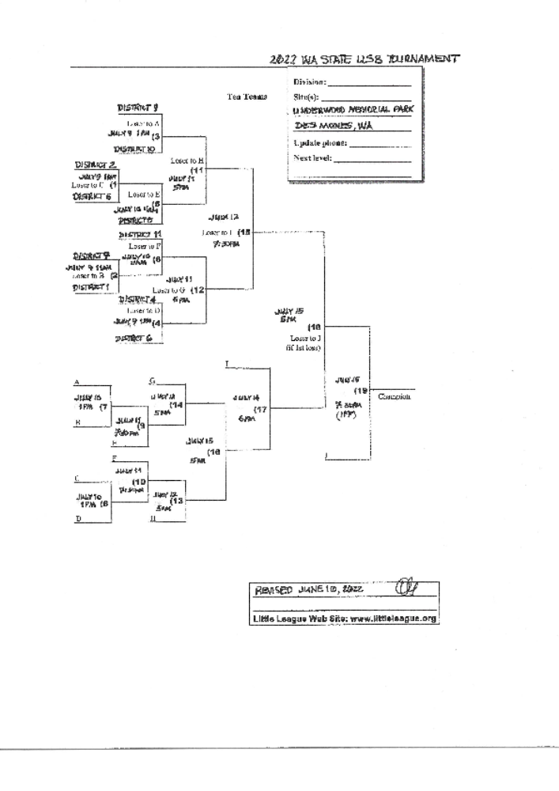

Underwood Park
Address: 21800 20th Ave S Des Moines WA 98198
Refreshments: A wide variety of food and refreshments are available at the food trucks.
Safety: For the safety and enjoyment of all who attend the following items are prohibited in the complex: alcohol, smoking, smokeless tobacco, chewing tobacco, sunflower seeds, fireworks, pets, large tarps, large containers, fireworks and weapons of any kind.

DIRECTIONS TO UNDERWOOD PARK
From I-5 southbound: Take exit 151 following signs for Military Rd/S. 200th St. Turn left onto Military Rd, then right onto S 216th St. Turn left onto 20th Ave S., the parking lot will be straight ahead.
From 1-5 northbound: Take exit 149B keeping to the right on the ramp onto WA-516/S. Kent Des Moines Rd. Bear right onto Pacific Hwy South, then left onto S 216th St. Turn left onto 20th Ave S. The parking lot for the park will be straight ahead.

HOTELS
Here are a few hotel offerings near Underwood Memorial Park, all received average to above average reviews. Please check each for pricing and special offers, as some offer no cost to children under 17.
Motels/Hotels
Best Western
20717 International Blvd. SeaTac WA
1-844-245-6623
Sheraton
22406 Pacific Highway S. Des Moines, WA
1-253-642-0100
Value Inn Seatac
22246 Pacific Highway S. Des Moines, WA
1-206-878-8427
Legend Motel
22204 Pacific Highway S. Des Moines, WA
1-206-878-0366
Camping
Saltwater State Park (4 miles away)
25205 8th Pl S. Des Moines WA
1-253-661-4956

