Celebrate Kirkland – City of Kirkland
John Chadwick, 2025 Grand Marshal
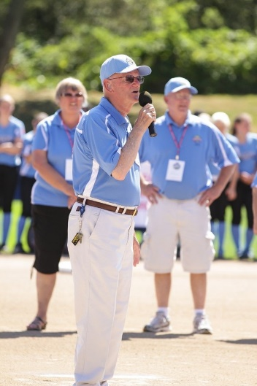
The City of Kirkland is proud to announce longtime Little League volunteer John Chadwick as the Grand Marshal for the 2025 Celebrate Kirkland Fourth of July Parade.
John has dedicated over five decades to youth sports, including 32 years as District Administrator for Washington Little League District 9 and more than 20 years as Director of the Junior League Softball World Series, an international event he helped launch and proudly brought to Kirkland in 1998. His leadership has elevated the visibility of girls’ sports and expanded opportunities for young athletes across the region.
John helped start Senior Baseball and Little League Softball programs, mentored thousands of volunteers, and grew local leagues from the ground up. Under his direction, the Junior League Softball World Series welcomed teams from across the U.S. and around the globe, bringing national attention and thousands of visitors to Kirkland each summer. Today, he continues to support the JLSWS tournament as Director Emeritus, offering guidance and encouragement to new leaders. Throughout it all, John’s late wife Ann was a steadfast volunteer by his side, both of them embodying the spirit of service they held dear.
One of John's greatest joys is running into former players who remember their Little League days. "It fills me with pride when a young person comes by me today and says, 'Hi Mr. Chadwick, I played in the Little League while you were District Administrator, and I enjoyed it very much.'" For John, that kind of connection is the heart of his work. "We as adults need to remember that it’s for the kids, and that’s what makes it good to be a small part of Little League."
John’s legacy has helped shape Kirkland as a place where youth, equity, and community thrive. His efforts have strengthened local athletic programs and brought lasting recognition to Kirkland as a host city and champion of girls' sports.
We are proud to have John Chadwick lead the 26th Annual Celebrate Kirkland Parade as the Grand Marshal. Be sure to give him a warm wave of thanks for his many contributions to Kirkland at this year’s event!
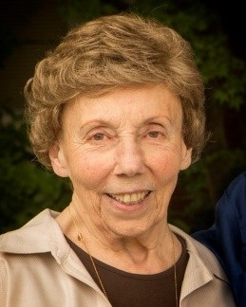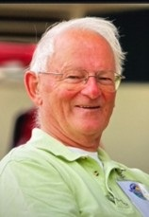
John's late wife Ann. Included in honor of her memory, Ann Chadwick is remembered for her many years of support to John and the community.

