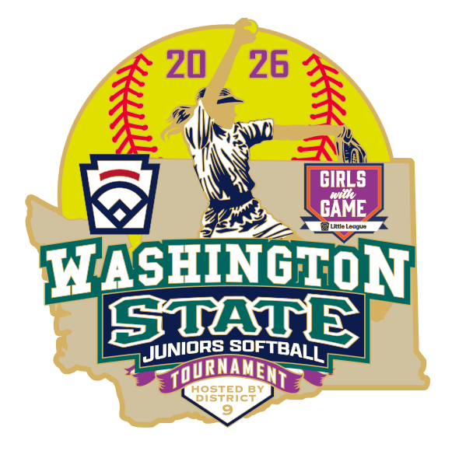




June 24, 2026

Washington State District Administrators:
Junior Softball WA State District Champion Managers:

District 9 is hosting the 2026 State Softball Juniors Tournament at Big Finn Hill Ball Fields at 8251 NE 138th St, Kirkland, WA.

The tournament is scheduled to start on Saturday, July 11th and is scheduled through Saturday, July 18th.

The bracket is enclosed at the end of this packet and is also available on the Washington State Little League website (https://littleleaguewash.org). This is a randomly drawn 9 team Little League double elimination bracket.

Please ensure this packet gets to your Softball Juniors District Champion promptly. Also confirm that the Manager reads and understands everything that is in this packet, as it provides all the info about the State Tournament, the schedule, the tournament facility, area hotels, along with area and contact info.

District 9 will not provide housing for any of your teams. Area hotel lists are included in the Manager packet.

There are two time-critical items that the Manager needs to handle, which are listed in the packet:
- Full Roster and name pronunciation, with a color team photo in JPG format suitable for printing in a possible program. We also want a photo-ready JPG image of your league logo. This is all due by EOD on Friday, July 3rd, to Russ Paul-Jones at russ@d9ump.org.
- With the tournament beginning on Saturday, July 11th, there will be a MANDATORY Manager meeting the evening before the tournament.
Friday, July 10th at 6:00pm @
Finn Hill Middle School.
8040 NE 132nd St
Kirkland, WA 98034
At this meeting, the Managers will be required to turn in their Team Affidavit packets for a quick review and State signatures. My staff and I will review the State tournament process and rules. Official Coaches are also invited. No Players please.

If you want to send umpiring crew(s) to the State tournament, please contact Robert Little at rlittle@d9ump.org or Russ Paul-Jones at russ@d9ump.org .

We at District 9 look forward to welcoming your District Champions to the State Tournament.

Bob Toigo
District Administrator
Washington District 9 Little League
(206) 799-4050
da@washdist9.org
www.littleleaguewashD9.org

Managers and Coaches Meeting
- Mandatory Managers Meeting
Friday, July 10th @ 6:00PM at Finn Hill Middle School, 8040 NE 132nd St, Kirkland, WA 98034.
- At this meeting, the Managers will be required to turn in their Team Affidavit binders for a quick review and State signatures. My staff and I will review the State tournament process and rules. Official Coaches are also invited. No Players please. The small nit-picky problems that can arise at these tournaments can be attributed to a manager or coach who is not present at this meeting.
- Your Team Affidavit Binder should include:
  - Team Affidavit, including the map, combined tournament team form (if needed)
  - Player affidavits with all supporting documentation
  - Proof that the coaches took the Little League Training for Diamond Leader and Abuse Awareness. LL does NOT accept the USA Baseball/Softball Abuse Awareness training.
  - Ensure that all your teams documents are signed by your League President and District Administrator.
  - Medical Release Forms
  - This tournament packet
- Once your documents have been verified and approved, they will be returned to you. It will be your responsibility to take care of these things.

There will NOT be any Opening Ceremonies.

Tournament Information - State brackets will be updated at the end of each day on the Washington State website under State Tournaments (https://littleleaguewash.org) . There will also be brackets posted at the facility near the Concession stand wall.
Managers and Coaches are responsible for knowing the current year’s Little League Baseball/Softball Rules and Regulations, including all tournament rules. See the bottom of this packet for links.

Sportsmanship
- Good sportsmanship is expected from all participants: managers, coaches, players, umpires AND parents. Any unsportsmanlike conduct will not be tolerated and will be communicated back to your home District Administrator and League President. Managers are responsible for the team’s conduct and that of their parents.
- Should any of your fans get out of control and cause problems your League President, District Administrator, and or your Team Manager will be asked to handle and correct the disturbance. If this is not successful, the Host Tournament Director and District Administrator will ask the offending person(s) to leave the facility. The last resort will be to contact Law Enforcement.

Electronic Devices:
- The only devices allowed are one-way pitch comms. The use of any other electronic communications during the game is prohibited. You cannot receive any communication (electronic or otherwise) from outside of the field/dugout area.
- Penalty: The penalty is ejection from the game. (3.17)
- A manager or coach is permitted to use a rulebook, scorekeeping, and/or pitch-counting application on an electronic device without penalty, provided such devices are in airplane mode and NOT used to send or receive messages.

Big Finn Hill Ballfields
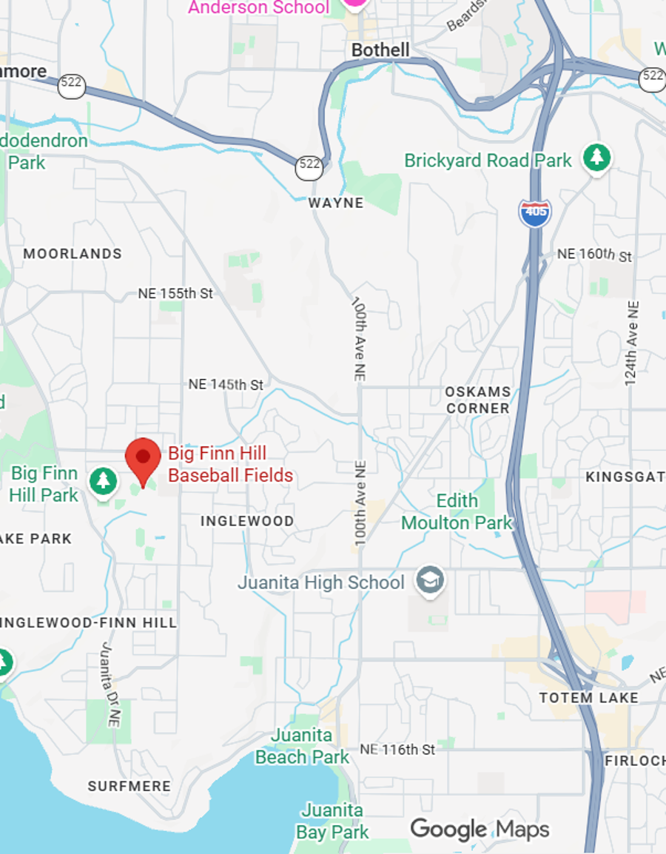

Big Finn Hill Ball Fields
For Internet or GPS Driving Directions Please use the following address:
8251 NE 138th St.
Kirkland, WA 98034
Entrance is just beyond Thoreau Elementary School.

Big Finn Hill Ball Fields
8251 NE 138th St., Kirkland, WA 98034

- Big Finn Hill Ball Fields are home to Kirkland National Little League.
- Field info: dirt infield, grass outfield, 43’ pitching rubber with circles, safety base at 1st base, bullpens.
- Field usage is for actual All Star tournament games and designated pre-game prep warmups ONLY.
  - Team practices and/or batting practices are not allowed on any field in the facility. There is no drop-in practice or other field usage allowed.
- Concessions are available on location.
- Water will be provided in each dugout for each game.
- Restrooms are located in building opposite concessions.
- NO alcohol, marijuana or tobacco products including vaping. If parents/spectators are caught, they will NOT be given any warning; the item(s) will be confiscated and disposed of, and the offenders will be ejected from the facility.
- The scorekeepers table area behind the backstop is for approved Tournament staff ONLY.
- Please return all foul balls to the scorekeepers table behind the backstop. Trade it in for candy!
- There will be a Tournament bracket posted on the side of the building at the field.
- Please clean out the dugouts after your game. There will be plenty of trash cans nearby.
- There are spectator stands in the infield and outfield areas. Please do not setup seating near or on the bullpens.
- You are welcome to hang and display team banners and All-Star items on the outside of the field fencing and dugouts, so long as they are not blocking the view of others.

*** PARKING ***
  - Parking is available near the fields.
  - Do not park in spaces designated for tournament staff or umpires.
  - Additional parking at Thoreau Elementary is available as well as on the other side of the park.

Game Streaming:
GameChanger streaming cameras may not be set up behind home plate or near the scorers table. Please set them up on your side of the field in front of your stands.

Area Parks and Ball Fields for practice:
With team practices and batting practices not allowed on the tournament fields…

Here are some nearby parks and area fields that your team can have an informal practice or warm up on before coming to the tournament facility. These are NOT reserved for you because your personal schedule is up to you. Use at your own risk. Show up and if nobody is there…
- Kirkland 132nd Square Park: https://www.kirklandwa.gov/Government/Departments/Parks-and-Community-Services/Find-a-Park/132nd-Square-Park
- Finn Hill Middle School: 8040 NE 132nd St, Kirkland, WA 98034.
- Thoreau Elementary: Dirt field on premises.
- Kamiakin Middle School: 14111 132nd Ave NE, Kirkland, WA 98034. Lots of open space and 2 fields in the back.
- Juanita Beach Park Fields: 11719 97th Ave NE, Kirkland, WA 98034.
- Crestwoods Park Athletic Fields: 1818 6th St, Kirkland, WA 98033.
- If you are just looking for grass fields (no ball fields): 60 Acres Park, 15200 NE 116th St, Redmond, WA 98052. Huge grass soccer complex on both sides of the street.

Area Batting Cage Facilities / Rentals
- EL1 Sports / Mariners Training Center
https://www.el1sports.com/facilities/mtc-woodinville/
14220 NE 193rd Place, Woodinville, WA 98072
(425) 485-0331

https://www.el1sports.com/facilities/mtc-redmond/ 15046 NE 95th St, Redmond, WA 98052
(425) 201-4145
- D-Bat Bothell https://dbatbothell.com/
18421 Bothell Everett Hwy #150, Bothell, WA 98012
(425) 448-3228

Local nearby Hotels/Motels

Baymont Inn by Wyndham 12223 NE 116th St  Kirkland, WA 98034  425-947-1030 | Country Inn & Suites by Radisson  19333 North Creek Parkway  Bothell, WA 98011  425-485-5557
Residence Inn by Marriott  11920 NE 195th St  Bothell, WA 98011  425-485-3030 | Holiday Inn & Suites  3850 Monte Villa Parkway  Bothell, WA 98021  425-398-9700
Courtyard by Marriott
11215 NE 124th St
Kirkland, WA. 98034
425-821-7870

Tournament Details and Reminders
- We will review the team affidavits at the managers’ meeting. If yours is not complete or you need to add or replace a player, coach or manager, you need to bring the pertinent information (for players: original birth certificate – not a copy, 3 proofs of residency or school form, medical releases, regular season team and games played, LL Certificates for Diamond Leader Training and Abuse Awareness Training) along with a note from your league president or board member stating that the player, coach or manager is eligible to a tournament official at the tournament table for approval. Please come well in advance of game time to allow for the paperwork to be processed.

- For each game, turn in your Team Affidavit packet and its sleeve protector one hour prior to gametime, when you will also turn in your lineup card and we will do the coin flip. At the end of the game, please return to the Tournament Table to sign the pitching record and pick up your lineup card for the next game.
- Managers or a team representative MUST report to the Tournament Director ONE hour prior to the scheduled start of their game for the coin toss at the Tournament Table at the fields. The team at the top of the game bracket will make the call. If you are not present at the designated time for the coin toss, the choice of home or away will be awarded to the team that is present at 55 minutes prior to game time.

- Lineup Cards: The tournament will provide the official lineup cards to use, and ONLY these may be used for each game for tournament officials, staff, umpires, and the opposing team. DO NOT use your own. You will receive a couple of copies at the Mandatory Managers meeting prior to the start of the tournament.
  - For each game, the lineup cards must be filled out completely using first and last names, uniform numbers, and their initial numerical defensive position. Please use standard 1 through 9 designations for the defensive positions in lieu of p, c, 1b, etc.
  - Your completed lineup card is required to be turned in at the Tournament table one hour before game time to compare to the team affidavits, review pitcher eligibility, and allow the official scorebook to be filled out. Starting lineups are not official until the umpires’ pre-game meeting at the plate. Changes can be made to the official book or lineup cards before that time.
- After each game, the manager MUST report to the tournament table and initial their team’s affidavit pitching record before leaving the facility. This is also when you can pick up a line-up card for the next game, or when you will pick up your team affidavit if you are heading home for the summer. Managers who fail to verify the pitching for that game and initial the Affidavit will be conceding that the pitching record entered on the Affidavit is correct.
- It is the managers’ responsibility to verify their pitcher’s eligibility before the beginning of each game. Pitching needs to be verified after completion of each game. If there are any discrepancies, they will be corrected at that time. The Official Scorekeeper’s scorebook takes precedence over the team scorebook. Game Changer data will not be allowed or utilized for this.

- No teams are allowed onto the field or in the dugouts until after the home/visiting teams have been determined via the coin toss.

- After the coin-toss, the Home team will occupy the third base dugout and the Visiting team will occupy the first base dugout.
- After the coin toss, each team can enter their respective dugouts. They may use their respective half of the outfield ONLY to warm up until 30 minutes prior to game time. No infield usage, yet, and no usage of foul territory in front of the dugout during that time. No player should have a bat in their hand. Any player acting as catcher while a coach is hitting balls must wear an approved Catcher mask with a dangling throat protector.

- The Visiting team will take infield/outfield warmup starting 30 minutes prior to game time, and the home team will do the same at 20 minutes prior to game time. This will be announced for each field for each game via the PA system. Each team is allowed 10 minutes. During this time, the opposite team must remain in their dugout. Players must act as catcher for the coach during field warmups and must wear an authorized catcher’s mask with a dangling throat guard.

- Pitchers and Catchers can warm up in their respective bullpens. This is players only. Catchers must at a minimum have their approved catchers helmet on with a dangling throat protector. Adults are NOT permitted to warm up their pitchers or catchers at any time, before or during the game.
- As per Little League Rule for 2025, there will be no equipment checks prior to each game. Umpires have been explicitly instructed by Little League to not check equipment. If you have a question about a specific piece of equipment, let the umpire staff know and they can give you an opinion on that item.

  - The Manager of each team is responsible for ensuring that all equipment is legal and proper for play according to Little League rules. Penalty: If illegal equipment is used during the game, the manager and player who used the illegal equipment will be ejected. The Manager and Player will also be suspended for their team’s next game (3.01 a), and the manager will be removed for the remainder of the international tournament TPR 3(g)/3(h).
- The umpires will conduct their plate meeting immediately before the game. Lineups will already have been exchanged at the 1 hour pregame meeting, but they are not official until the plate meeting. You can make changes at the plate meeting.

- Only rostered coaches listed on the Team Affidavit are allowed on the field, which includes the dugout and bullpen areas.

- Full team introductions for each team will occur at the start of each game. During Championship and Elimination games, each player will be announced and congratulated for a great tournament. All player introductions will occur with the team lining up on their respective baseline as they hear their name. We will also play the National Anthem and recite the Little League Pledge.
- During the game, it is mandatory in accordance with the rules that there be at least one rostered coach in the dugout at all times if there are players there.

- Catchers must wear an approved catcher’s helmet in accordance with Little League rules. Dangling style throat protectors are required on all catcher’s helmets. Any player acting as a catcher is required to wear a catcher’s helmet. This includes the catcher in his or her position at home plate and any other player who is catching for the manager and/or coach hitting to the infield or outfield. Bullpen catchers are required to wear an approved catcher’s helmet while warming up a pitcher.
- Any position changes or courtesy runner announcements will go through the home plate umpire. If the game is live, please ask the umpire for timeout and then approach the home plate and scorekeepers table area. The home plate umpire will then inform the official scorekeeper of all changes.
  - If you are changing pitchers or catchers, the moment this is determined, please approach the Umpire and Scorekeeper to announce. DO NOT wait until inning warm-ups are completed and the inning is ready to start before announcing your changes.
- The official scorebook will be kept by the Tournament staff at the scorekeepers table directly behind home plate. We use paper only.

- There is no contact between those in the spectator areas and those on the field or in the dugouts (Manager, Coaches, players). This also includes the team scorebook. If a team wishes to keep their own scorebook, it must be done by the manager, coach or player in the dugout without any contact with anyone outside of the field.

- You are expected to have your players hustle on and off the field. This will go a long way in preventing game delays. If you delay getting your team ready on defense, such as if you are having a team huddle, the Umpire may shorten the time for warmup pitching. Use your time wisely.
- During the game, the coaches, and players must stay inside the dugout at all times unless they are on the field on defense, on offensive play at bat, on the bases, or as a base coach. While on offense, any player on the field must wear a helmet and keep the helmet on until he is back inside the dugout. This includes players acting as base coaches. Players not actively participating in the game must not leave the dugout without the permission of the umpire (including to move to/from the bullpen for warm-up or go to the bathroom) and may not return to the dugout without the umpire’s permission.
- Bat boys/girls are not allowed. Players should return bats to the dugouts (next batter, batter that came home). Remember - If there are coaches at both first and third bases, the 3rd team coach must stay in the dugout—they are NOT allowed to come out of the dugout to retrieve bats or other equipment. Have the next batter retrieve the bat from the previous hitter, if necessary.

- The LITTLE LEAGUE OFFICIAL RULES AND REGULATIONS will govern how protests are handled. Protests of judgment calls will not be considered. If the Manager feels that they have a legitimate protest involving a rule infraction or interpretation, please ask the Umpire for time, and once given, then approach the Umpire to discuss in a reasonable tone. Please indicate the location of the rule in the Official Rules and Regulation documents. All legal protests must be lodged by the Manager before the next pitch, play or attempted play in the game. Protests lodged after play has continued will not be allowed. The burden of proof will be the responsibility of the Manager lodging the protest. ALL PROTESTS MUST BE RESOLVED BEFORE THE GAME WILL BE ALLOWED TO CONTINUE. Only the Manager may protest or ask for clarification on a ruling—NOT the coaches.

- In case of an injury to a player on the field, only the coaches will be permitted on the field to attend to their players. If additional medical attention is needed, it will be handled at that time. All play must have ceased and time called by the umpire before the manager will be allowed on the field.
- If a player is removed from the game due to an injury, the player must have a signed, doctor’s release before
he/she is allowed to resume play.

- All softballs hit outside of the field of play must be returned to the scorekeepers table behind the backstop. DO NOT encourage anyone to give them directly to the team or hand them into the dugouts. We trade with candy!

- Per Little League Tournament rule, please remind your team parents that we welcome their positive cheering and rooting on their players and team, but there is to be NO coaching or communications from
The stands into the field of play, into the dugouts or bullpens. This includes such things as a parent yelling to ask
for an appeal at 1st or 3rd, telling their player to choke up, reminding them of what a certain player did the last
time they were up to bat or yelling out “Infield Fly”. Let the coaches coach, let the players play, let the
Volunteer Umpires be Umpires and keep everything positive.

- All game participants and spectators are expected to display GOOD SPORTMANSHIP while at the tournament site and elsewhere. We expect the conduct of yourself, players, and spectators in the stands to be exemplary. Abusive language, trash talking and /or taunts directed at the umpire or opposing team will not be tolerated.
- All umpires and tournament staff are volunteers. Please respect them and thank them for their time and commitment to Little League. It is likely that some umpires have travelled to Woodinville from across the state for this tournament.

- Team practices and/or batting practices are not allowed on the tournament fields.

Mercy Rule, per the Rule Book:
  - 15 runs at 4 complete innings (3 ½ if the Home team is ahead)
  - 10 runs at 5 complete innings and beyond (4 ½ if the Home team is ahead)

- If not called out above, refer to the Little League Rules:
  - https://www.littleleague.org/tournament-resources/
  - https://www.littleleague.org/downloads/tournament-rules-softball/
  - https://www.littleleague.org/downloads/2026-rulebook-significant-changes/
  - https://www.littleleague.org/university/articles/regular-season-to-tournament-rule-differences/
  - https://www.littleleague.org/help-center/international-tournament-faqs/

- Carry your medical releases with you. Local hospitals may delay treatment without parent or guardian authorization or an authorized medical release.

- Please inform your team, parents and fans of all the above rules.

Tournament Player Team Roster

We need three things emailed to us by EOD on Friday, July 3rd:
- Please fill out the roster and pronunciation information below. Please type it or make it very legible. Do not take a photo of this and send it.
- A color picture of your District Champion team. JPG format preferred.
- A photo-ready JPG image of your league logo (not just copied from your website).

Russ Paul-Jones
programs@washdist9.org
(206) 595-5669

2026 Washington State Junior Softball
ALL-STAR TOURNAMENT PROGRAM ROSTER
District Number:
District Administrator:
League Name(s):
Hometown:
President(s):
 | First Name | Last Name | Pronunciation for our Announcers
Manager Name:
Email address:
Cell Phone Number:
Coach 1 Name:
Coach 2 Name:
Jersey Number | First Name | Last Name | Pronunciation for our Announcers

